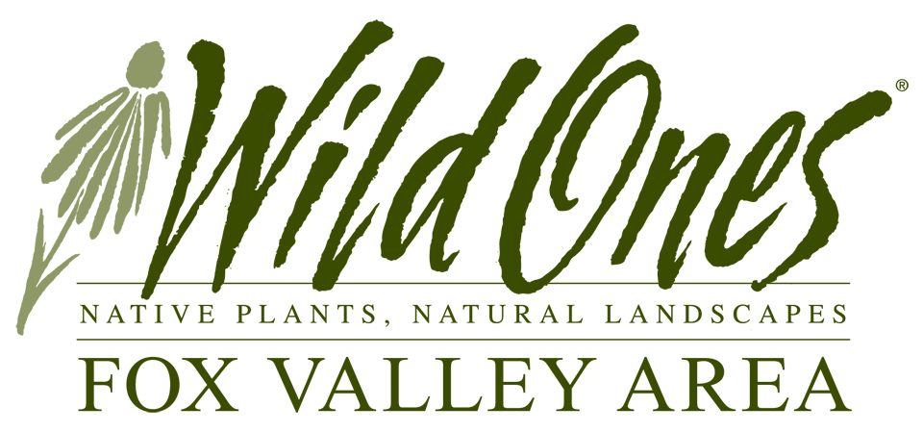
Natural Landscapes for Tomorrow
Grant APPLICATION
Project Title:
School/Organization:
E‐mail Address:
Brief Summary of Project:
Project Duration From: |  |  |  |  |  |  |  | To: (for first year establishment)
Total Project Budget: |  |  |  |  |  |  | Amount Requested:

Your Organization
Organization Name: |  |  |  |  | Founded:
Street Address:
City, State ZIP:
Phone: |  |  |  |  | Website: | /

Your Project Coordinator
Name: |  |  |  |  | Title:
Street Address:
City, State ZIP:
Phone: |  |  |  | E‐mail:

Authorization
I understand that awarding of grants and amount of grants shall be subject to the sole discretion of the Natural Landscapes for Tomorrow Committee. I also understand project descriptions become the property of the Committee and, if I am awarded a grant, the Committee shall have the right to supply others with a description of the project and disseminate its underlying concepts and/or ideas. If awarded a grant, I agree to acknowledge this funding source in any project publicity or printed or online materials, and submit an expense accounting within one year of the date of the award letter. The Committee and sponsors and/or any of its agents, officials, and employees shall assume no responsibility or liability for claims of damage of any kind to property or for claims of injury to any person in connection with a grant. This project is being sponsored by a not‐for‐profit organization.

Authorized person’s signature |  |  | Date
Print authorized person’s name |  | Position:

Project Details

- Goals
Describe the goals of the project, including how it will enhance the educational use of the area involved as applicable.

- Site Description
Describe the site, the kinds of habitat and plant communities being restored, and the effect on wildlife.

- Preparation Methods
Describe the planned site preparation including the following: what and how any invasive plants will be eliminated; method of planting (hand seed, plant plugs, no drill, etc.); a timeline; and the planned short-term maintenance of the project.

- Site Management
How will the area be managed for invasive species and general maintenance for the long‐term? Who will be responsible? What is the long‐term funding plan?

- Description of Project Area as it currently exists
Provide photos or a diagram of the entire area you intend to utilize as a nature area as it currently exists including dimensions for site. Please describe the immediate area surrounding the project site. Show the significant existing natural and human-made features. Be sure your diagram includes scale, and also include direction points, (North, East, South, West). Note what vegetation, if any, will be eliminated. Label sketches, photos, etc. as “before.”

- Project Design
Provide sketch or diagram of the work plan for the project area. Show or describe the landscape as it will appear when the grant project is completed. Identify the physical structures that will be constructed and vegetation that will be planted. Include scale and directions.

- Wild Ones Budget
List plants or seeds needed for this project. Be sure to include Latin name, number of plants and estimated cost below or on a separate page. (Forbs can be purchased through Wild Ones Fox Valley Chapter Plant sale at a reduced cost of ____ per plant. See website for plant list).

Plant Name | Latin Name | Number  of Plants | Retail  Price | Estimated  Cost
 |  |  |  | $
 |  |  |  | $
 |  |  |  | $
 |  |  |  | $
 |  |  |  | $
 |  |  |  | $
 |  |  |  | $
 |  |  |  | $
 |  |  |  | $
 |  |  |  | $
 |  |  |  | $
 |  |  |  | $
 |  |  |  | $
Total

- Other Requirements for Project Completion
To help us know the scope of your project, please list other requirements needed as well as revenue
sources and amounts.

Item | Revenue Source | Amount
 |  | $
 |  | $
 |  | $
 |  | $
 |  | $
Total Amount for Ineligible Costs |  | $

- Total Project Costs

Amount Requested from Wild Ones Fox Valley Chapter | $
Project Amount from Other Sources | $
Total | $

Instructions to Submit your Application
IMPORTANT—Please submit your application to Wild Ones through e-mail. After completing this form, save it to your hard drive (in Windows, use File - Save.) You may customize the file name if you wish. Attach it to an e-mail message along with any pictures or diagrams and send to wildonesfoxvalley@gmail.com.

Send your completed application and attachments no later than midnight on February 1st.

