**Backyard Plan for Sunny Area KIT 4**

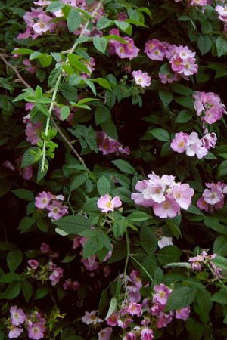

**Climbing Rose rosa setigera**

|  |  |
| --- | --- |
| Light: | Full Sun, Partial |
| Soil: | Sand, Loam, Clay |
| Moisture: | Dry, Medium, Moist |
| Benefits: | Butterflies, Pollinators, Birds |
| Height: | 4'-15' |
| Blooms: | Jun, Jul |
| Zones: | 4, 5, 6, 7, 8 |

**Switchgrass panicum virgatum**

|  |  |
| --- | --- |
| Light: | Full Sun |
| Soil: | Sand, Loam, Clay |
| Moisture: | Dry, Medium, Moist |
| Benefits: | Birds, Deer Resistant |
| Height: | 3'-6' |
| Blooms: | Aug, Sep |
| Zones: | 3, 4, 5, 6, 7, 8, 9, 10 |

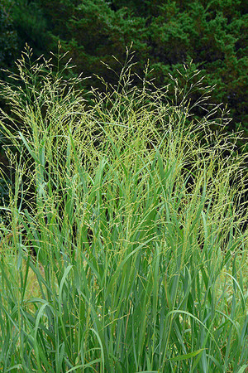

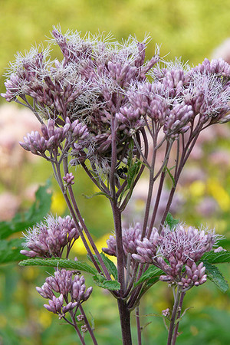

**Joe Pye Weed eupatorium maculatum**

|  |  |
| --- | --- |
| Light: | Full Sun |
| Soil: | Sand, Loam, Clay |
| Moisture: | Moist, Wet |
| Benefits: | Butterflies, Pollinators |
| Height: | 4'-6' |
| Blooms: | Aug, Sep |
| Zones: | 3, 4, 5, 6 |

**Butterfly Weed asclepias tuberosa**

|  |  |
| --- | --- |
| Light: | Full Sun |
| Soil: | Loam, Clay |
| Moisture: | Medium |
| Benefits: | Butterflies, Pollinators, Birds, Hummingbirds, Deer Resistant |
| Height: | 2'-3' |
| Blooms: | Jun, Jul, Aug |
| Zones: | 3, 4, 5, 6, 7, 8, 9, 10 |

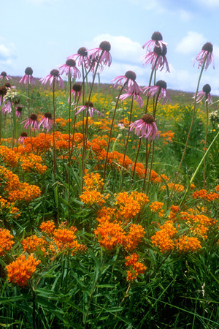

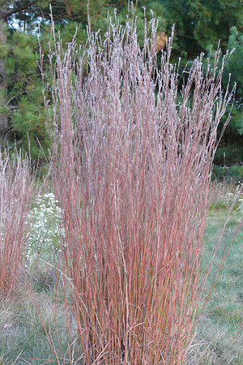

**Little Bluestem schizachyrium scoparium**

|  |  |
| --- | --- |
| Light: | Full Sun |
| Soil: | Sand, Loam |
| Moisture: | Dry |
| Benefits: | Deer Resistant |
| Height: | 2'-3' |
| Blooms: | Aug, Sep, Oct |
| Zones: | 3, 4, 5, 6, 7, 8, 9, 10 |

**Coreopsis coreopsis palmata**

|  |  |
| --- | --- |
| Light: | Full Sun |
| Soil: | Sand, Loam |
| Moisture: | Dry, Medium |
| Benefits: | Butterflies, Pollinators |
| Height: | 2'-3' |
| Blooms: | Jun, Jul, Aug |
| Zones: | 3, 4, 5, 6, 7, 8 |

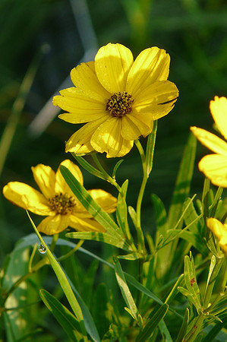

**Blazingstar liatris aspera**

|  |  |
| --- | --- |
| Light: | Full Sun |
| Soil: | Sand, Loam |
| Moisture: | Dry, Medium |
| Benefits: | Butterflies, Pollinators, Birds, Hummingbirds, Deer Resistant |
| Height: | 2'-5' |
| Blooms: | Aug, Sep |
| Zones: | 3, 4, 5, 6, 7, 8 |

