**Backyard Plan for Sunny Area KIT 2**

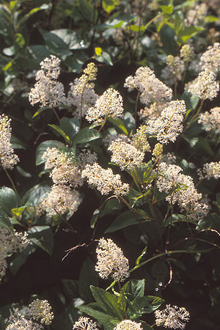

**New jersey tea ceanothus americanus**

|  |  |
| --- | --- |
| Light: | Full Sun, Partial |
| Soil: | Sand, Loam |
| Moisture: | Dry, Medium |
| Benefits: | Butterflies, Pollinators, Hummingbirds, Deer Resistant |
| Height: | 2'-3' |
| Blooms: | Jul, Aug |
| Zones: | 3, 4, 5, 6, 7, 8 |

**Blue false indigo baptisia australis**

|  |  |
| --- | --- |
| Light: | Full Sun, Partial |
| Soil: | Sand, Loam, Clay |
| Moisture: | Medium |
| Height: | 3'-5' |
| Blooms: | Jun, Jul |
| Zones: | 3, 4, 5, 6, 7, 8, 9, 10 |

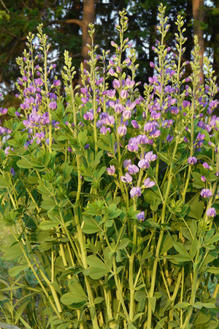

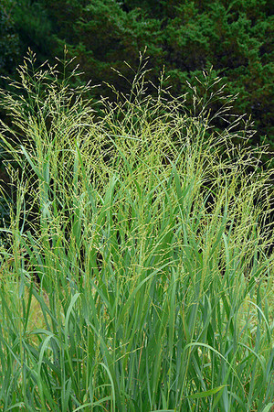

**Panicum virgatum switchgrass**

|  |  |
| --- | --- |
| Light: | Full Sun |
| Soil: | Sand, Loam, Clay |
| Moisture: | Dry, Medium, Moist |
| Benefits: | Birds, Deer Resistant |
| Height: | 3'-6' |
| Blooms: | Aug, Sep |
| Zones: | 3, 4, 5, 6, 7, 8, 9, 10 |

**Solidago regida stiff goldenrod**

|  |  |
| --- | --- |
| Light: | Full Sun |
| Soil: | Sand, Loam, Clay |
| Moisture: | Dry, Medium |
| Benefits: | Butterflies, Pollinators, Birds, Deer Resistant |
| Height: | 3'-5' |
| Blooms: | Aug, Sep |
| Zones: | 3, 4, 5, 6, 7, 8, 9 |

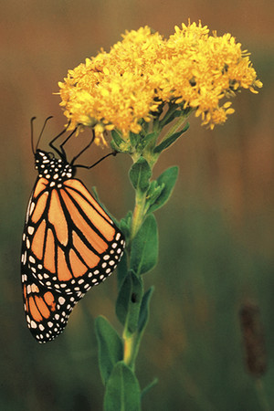

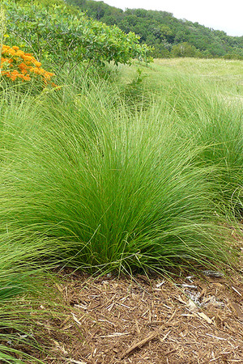

**Prairie drop seed sporobulus heterolepsis**

|  |  |
| --- | --- |
| Light: | Full Sun |
| Soil: | Sand, Loam |
| Moisture: | Dry, Medium |
| Benefits: | Birds, Deer Resistant |
| Height: | 2'-4' |
| Blooms: | Aug, Sep |
| Zones: | 3, 4, 5, 6, 7, 8 |

**New England aster aster novae-angliae**

|  |  |
| --- | --- |
| Light: | Full Sun, Partial |
| Soil: | Sand, Loam, Clay |
| Moisture: | Medium, Moist |
| Benefits: | Butterflies, Pollinators, Birds |
| Height: | 3'-6' |
| Blooms: | Aug, Sep, Oct |
| Zones: | 3, 4, 5, 6, 7 |

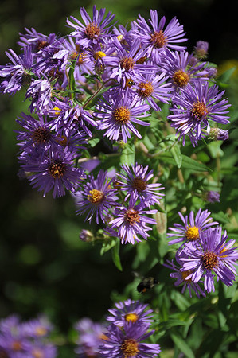

**Coneflower echinacea purpurea**

|  |  |
| --- | --- |
| Light: | Full Sun, Partial |
| Soil: | Sand, Loam, Clay |
| Moisture: | Dry, Medium |
| Benefits: | Butterflies, Pollinators, Birds, Hummingbirds, Deer Resistant |
| Height: | 3'-4' |
| Blooms: | Jul, Aug, Sep |
| Zones: | 4, 5, 6, 7, 8 |

